Schools carried forward to the 2024-25 list from 2023-24 list

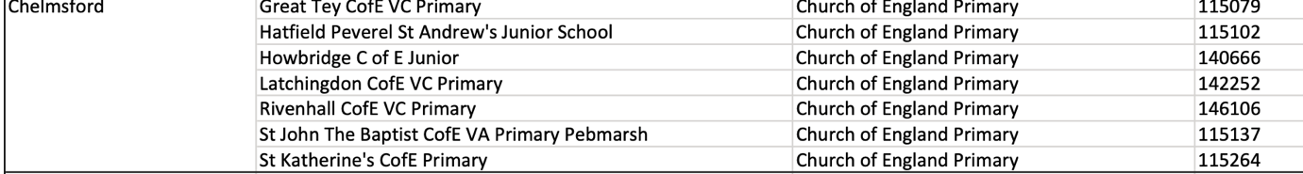

Schools to be inspected list 2024-25

